Confidence-Based Model Fusion for Robust Adversarial Detection in Multi-Controller SDNs

Mr.M.V.Balaganesh BTech, MTech,Assistant Professor, Shinmaya K.B ,Shree Harini.K ,Varsha G. A
Student Members, Department of Information Technology of Mepco Schlenk
Engineering College

Abstract— Machine Learning (ML)-based Network Intrusion Detection Systems (NIDS) are increasingly deployed in Software-Defined Networks (SDNs) to detect anomalous traffic. However, adversarial poisoning attacks such as Random Label Manipulation (RLM) can compromise model integrity, especially in Multi-Controller SDN (MSDN) environments. The Trans-controller Adversarial Perturbation Detection (TAPD) framework addresses this by transferring models across controllers and using voting to identify compromised nodes. Yet TAPD treats all controller votes equally, ignoring model reliability. In this paper, we propose Confidence-Based Model Fusion (CBMF), a novel enhancement to TAPD that weights each controller’s vote by its confidence score derived from self-evaluation error. CBMF improves detection accuracy by reducing the influence of compromised controllers. We validate CBMF on the UNR-IDD dataset and demonstrate significant improvements in detection precision, recall, and robustness under varying attack intensities.

Index Terms—Software-Defined Networking (SDN), Multi-Controller SDN (MSDN), Network Intrusion Detection System (NIDS), Adversarial Machine Learning, Random Label Manipulation (RLM), Trans-Controller Adversarial Perturbation Detection (TAPD), Confidence-Based Model Fusion (CBMF), Confidence-Weighted Voting, Poisoning Attack Detection, Interquartile Range (IQR), Confidence Reliability Estimation, Distributed Controller Security, UNR-IDD Dataset, Model Aggregation, Robust Machine Learning.

s

I.INTRODUCTION

oftware-Defined Networks (SDNs) has restructured modern network management by separating the control and data planes, thus allowing greater programmability, central control, and flexibility in network operation. In the software-defined architecture, network switches work under the control of a centralized controller in SDN, which undertakes the responsibility of managing traffic with the help of flow tables. This makes the task of network configuration much easier, with increased capacity for traffic analysis, anomaly detection, and performance optimization. The ever-increasing complexity of network infrastructures has widespread repercussions in the SDN industry, with the market continuing to grow rapidly and expected to attain a global value of 35.6 billion USD by 2026.

MSDNs have also been put forward to meet the ever-increasing needs in terms of scalability and reliability as an extension of standard SDNs. Here, under this architecture, there are controllers that collaborate with each other to control distributed parts of the network, hence providing reduced processing burdens and fault tolerance. In our project, this multi-controller situation is simulated with several hosts under one controller, where each host represents a sub-network or domain controlled by one controller in real-world situations. This simplifies it to implement while still possessing logical performance of an MSDN environment. Each host in the testing environment has a Machine Learning (ML)-driven Network Intrusion Detection System (NIDS) that monitors and tags network traffic as normal or malicious. With increased deployment of ML models, however, comes the increasing need to defend against adversarial attacks on network security. Random Label Manipulation (RLM), a form of attack, manipulates training labels with the intention to bias decision boundaries, decreasing model accuracy and causing mislabeling of malicious packets as normal.

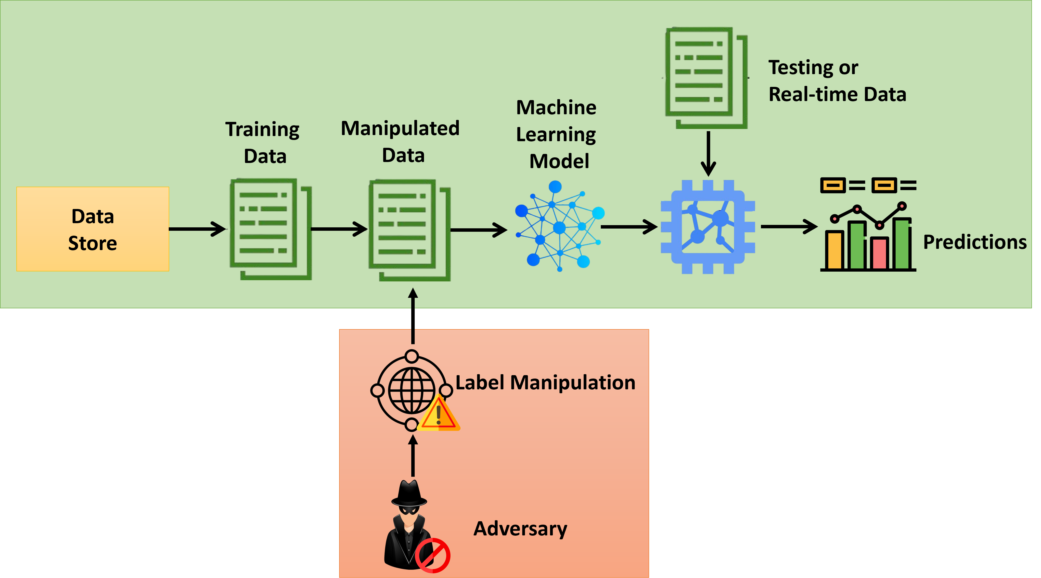

Fig. 1 Label Flip Attack in Machine Learning Pipelines

As a solution to this issue, the Trans-controller Adversarial Perturbation Detection (TAPD) framework was introduced. TAPD utilizes model swapping and cross-validation across controllers for detecting inconsistencies caused by poisoned training data. Controllers evaluate other models, compute errors, and vote on their peers that are most likely to be adversarial. The final consensus determines malicious or untrustworthy nodes. While TAPD is effective for detecting poisoning attacks, it treats all controllers with an equal degree of reliability. Equal-weight voting leads to greater vulnerability to compromised nodes and, in return, brings about false detection, especially when multiple parties are under attack.
To overcome this constraint, we present herein the Confidence-Based Model Fusion (CBMF) framework — an extension to TAPD that incorporates controller reliability weighting into the voting process. Every node (or host within our simulation) evaluates its local model performance to get a measure of confidence, which is the inverse of its self-error. More confident nodes cast larger votes, coercing those unreliable nodes to have a negligible impact on the final decision.
By implementing confidence-based aggregation, CBMF achieves higher detection accuracy and immunity to poisoning by adversaries. Even in a small MSDN simulation scenario with multiple hosts under a single controller, the approach demonstrates improved robustness, accuracy, and stability and provides an effective and scalable defense mechanism to ML-based NIDS in SDN environments.

II. RELATED RESEARCH AND BACKGROUND

Adversarial poisoning attacks have become a primary concern in ML-based security systems, especially in NIDS. Among them, the so-called LM attacks-the adversaries intentionally manipulate or flip some training labels-are particularly dangerous because they degrade the performance of classifiers without visibly changing data distribution. In such an attack, the classifier will be tricked into recognizing malicious inputs as legitimate, reducing the overall reliability of ML-based NIDS.

A set of works have been performed in the context of defenses against LM attacks. Early works introduced optimization based poisoning attacks that maximized misclassification in models of supervised learning, extended later to GNNs and Naïve Bayes classifiers to show how label corruption impacts various architectures [30], [39]. However, the majority of current works focus on constructing and modeling the attack, rather than developing robust techniques for its detection.

The defense against LM and any other poisoning attacks can be intrinsically complicated because of the nonlinear and multivariate nature of the problem. For example, several countermeasures developed using adversarial training and gradient hiding enhance model robustness yet can still be broken by adaptive attacks or surrogate attacks that provoke the target model's behavior [35]. Similarly, other defenses based on feature squeezing and preprocessing can never work because label poisoning happens in model training, not feature-level manipulation [25].

In the domain of NIDS, a few works have focused on label poisoning defense. The class-label inconsistencies can be detected by the AWFC technique, but it proves computationally expensive for large-scale datasets [23]. The SecFedNIDS framework [24] exploits federated learning for distributed detection; however, this lacks scalability and sensitivity in scenarios where the data distribution is non-IID.

To this end, the Transfer-based Adversarial Perturbation Detection (TAPD) [31] was proposed accordingly for the case of Multi-Controller Software-Defined Networks. TAPD employs model transfer between controllers in doing cross-validation in order to detect deviations caused by poisoned models. Although it is very effective in this sense, it assumes that the controllers are equally trusted without considering variations in individual reliability.

The proposed CBMF framework extends TAPD with confidence-weighted voting. Different from TAPD, CBMF gives each controller a reliability score according to its self-evaluation error and uses it for aggregation to be more precise and avoid the poisoning influence. This leads to significant improvement in both detection accuracy and adversarial perturbation resilience while keeping the design lightweight and adaptive.

Complementary studies have explored related approaches in the field of distributed learning systems. Das et al. [31] also leveraged model transferability in TAPD for poisoned update detection but still applied equal voting, which is noise-sensitive in heterogeneous environments. Lv et al. [23] introduced AWFC for adaptive weight correction in federated settings, which introduces computational overhead. Zhang et al. [24] proposed SecFedNIDS, a method that allows the preservation of data privacy but faces challenges when dealing with unbalanced data.

These include other techniques like gradient hiding, adversarial training, and feature squeezing, which address model robustness without mitigating label-level corruption. MAD-based approaches improve statistical robustness by filtering out outliers, which are resource-intensive and hence inappropriate for real-time SDN environments.

Confidence-weighted ensemble techniques achieve dynamic weight adjustment based on the model reliability and thus outperform equal-weight ensembles; these have not been harnessed for multi-controller SDN contexts, in which such adaptive fusion can yield much improved poisoning resilience.

In a nutshell, none of the state-of-the-art defenses, ranging from transfer validation to gradient masking and robust aggregation, have achieved confidence-weighted model fusion in SDN-based adversarial detection.

This research gap motivates the development of the proposed CBMF framework, which is designed to enhance robustness and reliability in distributed controller environments.

III. PROPOSED SYSTEM MODEL

A. Emulated Multi-Controller SDN Framework
We employed in our project a simulated Multi-Controller Software-Defined Network (MSDN) architecture where a single SDN controller controls multiple hosts, each being a distinct controller domain logically. This is easier to realize physically without losing the logicality of an actual multi-controller SDN infrastructure.
The system has the following:
• Command Center: The command center is the managerial level that controls the SDN network. Command center is a centralized core of decision-making that collects feedback from all simulated controller nodes (hosts), monitors network health, and is responsible for detection functions.
• Control Plane (Controller Layer): Our simulation control plane is realized through one SDN controller managing a series of logical sub-controllers cloned on a number of hosts. Every host is an independent controller domain that is able to train and test its own Machine Learning (ML)-based Network Intrusion Detection System (NIDS).
• Data Plane: Real network entities such as routers, switches, and virtual hosts are kept in the data plane. These store traffic data used when testing and training a model. Traffic data for a segment of a sub-network is aggregated by a host.

B. ML-Based NIDS Pipeline
Each simulated controller node (host) within the system runs a Machine Learning (ML)-powered Network Intrusion Detection System (NIDS) that is specifically trained on its local share of the dataset. Training material is taken from the UNR-IDD dataset with 37,412 instances of network flows and 34 features utilized to describe a variety of benign and malware traffic patterns including TCP-SYN flooding, Blackhole, Flow Table Overflow, and Traffic Diversion.
The entire NIDS pipeline consists of the following steps:
• Data Collection: The traffic data of the local network is gathered by each host and used to train a local ML model (Random Forest classifier). The data is divided into small subsets, and each subset is attributed to the traffic behavior of a particular domain.
• Pre-processing data: Removing noise, normalization, and dividing the data into training and test sets. In this phase, Random Label Manipulation (RLM) attacks are simulated by random perturbation of a percentage of the training labels to mimic adversarial poisoning.
• Model Training: Each host trains its Random Forest model on its corresponding portion of the data. This provides slightly different decision boundaries for each model of a host, mimicking independent controller learning in an MSDN setup.
• Model Testing and Confidence Computation: Each host then checks its model performance versus its local test set and computes a self-error rate. A confidence measure is then computed therewith through the equation:

$${Confidence}_{i}=1/(1_SelfError_{i})$$

These confidence measures are then used during fusion.

• Confidence-Based Model Fusion (CBMF): Each host contributes its models for cross-testing. All the remaining hosts cross-test each model, and the results are consolidated at the command center. Rather than equal voting (TAPD), confidence values are used to provide weights to votes so that high-reliability models have more weight while detecting poisoned nodes. This pipeline allows us to explain realistic adversarial attacks in an SDN environment in a deployable and light-weight fashion with file-based or socket-based host-to-host exchange.

Table I. Dataset Description – UNR-IDD
Parameter | Description
Total Samples | 37,412
Total Features | 34
Feature Types | 5 categorical, 29 numerical
Attack Types | TCP-SYN Flooding, Blackhole, Flow Table Overflow, Traffic Diversion
Training/Testing Split | 80/20
Data Source | UNR-IDD Intrusion Detection Dataset

C. Assumptions
1. All simulated hosts are treated as individual controller domains although they all belong to a single SDN controller.
2. Data partitions of every host are treated as I.I.D. in order to enable equal comparison at the fusion phase.
3. Simulation is performed on a controlled setup without network delay or real-world routing latency to see only the ML model behavior and detection logic.

IV. PROPOSED METHODOLOGY: CONFIDENCE-

BASED MODEL FUSION (CBMF)

- Controller Topology and NIDS Deployment
The simulated Multi-Controller Software-Defined Network (MSDN) topology consists of multiple SDN domains denoted as $S=\{S_{1},S_{2},...,S_{N}\}$, each managed by an independent controller $C=\{C_{1},C_{2},...,C_{N}\}$. Among these, a subset of controllers affected by Label Manipulation (LM) or Random Label Manipulation (RLM) attacks is represented as $N^{'}⊂N$. The target Network Intrusion Detection dataset is defined as $X=\{x_{1},x_{2},...,x_{E}\}$, containing $E$samples with corresponding labels $Y=\{y_{1},y_{2},...,y_{E}\}$. The label set contains $F$unique classes denoted by $L=\{l_{1},l_{2},...,l_{F}\}$, where each label $l_{j}$is associated with $M_{j}$samples, satisfying

$\sum_{j=0}{M_{j}=E , j=\{0,1…F\}}$ (1)

B. Label-Flipping Attack Simulation
In this paper, the RLM attack is selected as the main threat model against LM. This type of poisoning attack considers the random modification or reassignment of a subset or all the training labels to wrong classes in the dataset. This attack scenario has been considered as the threat vector because of its novelty and increased relevance within the current adversarial machine learning research landscape [30], [39]. Although the proposed Confidence-Based Model Fusion framework has been mainly tested against RLM attacks, it is easily adaptable to other types of adversarial poisoning, such as targeted label manipulation, feature poisoning, data manipulation, and data injection.
To initiate an RLM attack, the number of labels to be maliciously altered must first be determined. For this purpose, we define $Θ$as the Attack Control Parameter, where $0≤Θ≤1$. The value of $Θ$represents the proportion of training samples from the dataset $X$that the adversary intends to corrupt. A smaller $Θ$value indicates that the attacker aims to modify only a few labels, attempting to remain undetectable while causing limited disruption. Conversely, a higher $Θ$value signifies that the attacker seeks to manipulate a larger portion of the dataset, inflicting greater model degradation at the cost of increased detectability. The total number of samples to be altered, denoted as $V$, can be determined using (2):

V = ceil(Θ x E) (2)

where $E$represents the total number of samples in the training dataset, and $V$is the total number of samples whose labels are changed by the adversary. Once $V$is determined, the attacker randomly selects these samples from the dataset and assigns them incorrect labels.
All simulated controllers then train their local ML-based Network Intrusion Detection Systems (NIDS) using their respective dataset partitions. However, only a subset of these models is trained on datasets affected by the RLM attack. We denote the set of all trained ML models as $Φ=\{Φ_{1},Φ_{2},...,Φ_{N}\}$, where each controller $C_{i}$hosts one local model $Φ_{i}$. After training, these models become finalized NIDS models, represented as $Δ=\{Δ_{1},Δ_{2},...,Δ_{N}\}$. Among these, a subset of compromised NIDS models that have been trained on poisoned data due to RLM are collectively denoted as $Δ^{'}⊂Δ$. These compromised models exhibit degraded performance and contribute to the propagation of errors within the multi-controller system, forming the core challenge addressed by the CBMF framework.

C. Confidence-Based Model Fusion (CBMF)
When Machine Learning (ML)-based Network Intrusion Detection Systems (NIDS) deployed across multiple controllers are exposed to adversarial poisoning attacks such as Random Label Manipulation (RLM), the resulting degradation in model accuracy can propagate across the entire Multi-Controller Software-Defined Network (MSDN). To mitigate this impact, it is essential to periodically verify the reliability of each controller’s ML model and minimize the influence of compromised peers during collective decision-making.
The Confidence-Based Model Fusion (CBMF) framework is designed to achieve this by extending the core principles of Trans-Controller Adversarial Perturbation Detection (TAPD) with a confidence-driven reliability weighting mechanism. Rather than treating all controller votes equally, CBMF assigns a dynamic confidence score to every controller based on its local self-evaluation performance. Controllers with lower self-error contribute higher weight during fusion, while those with poor accuracy or suspected poisoning contribute less. This confidence-aware design significantly reduces false positives and increases robustness under adversarial conditions.
The overall CBMF process—illustrated in Fig. 4—can be summarized as follows. The Command Center initiates the detection cycle by broadcasting a control request to all simulated controller nodes (hosts). Each controller trains its local ML-based NIDS using its partitioned dataset and reports its self-error and serialized model to the Command Center. Once models from all controllers are collected, they are distributed for cross-evaluation among peers using REST communication over localhost. Every controller evaluates the received models on its local test subset and generates an error matrix representing the mutual performance between controllers.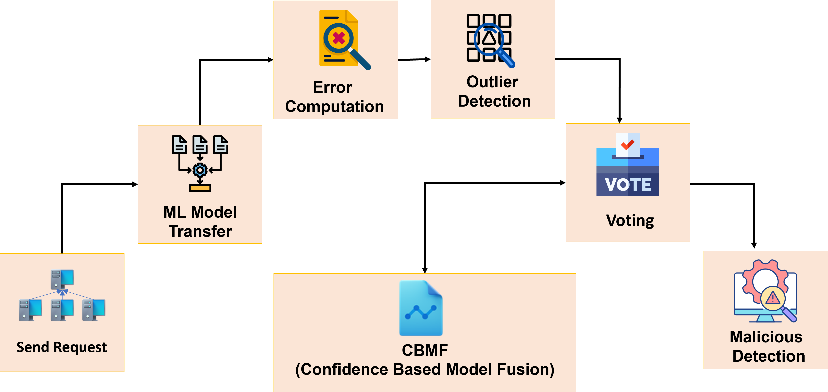

Fig. 4. CBMF framework stages

1)send request : In the simulated Confidence-Based Model Fusion (CBMF) environment, the Command Center initiates the detection cycle by transmitting asynchronous REST-based requests to all local controller hosts operating on different ports within the same physical system. Each local controller represents an independent SDN controller domain, such as localhost:8080, localhost:8081, or localhost:8082, thereby forming a logically decentralized but physically consolidated multi-controller setup. These REST-based initiation signals are implemented using Java HTTP clients to ensure lightweight and low-latency communication without requiring any physical Northbound or Southbound interfaces. Each initiation request contains all necessary parameters, including task identifiers, dataset paths, model configurations, and evaluation modes, to synchronize the training and evaluation processes across controllers. Once the Command Center dispatches these requests, every controller loads its assigned partition of the UNR-IDD dataset, trains a localized ML-based Network Intrusion Detection System (NIDS) using a Random Forest classifier, and subsequently stores the trained model within its internal workspace while exposing it through an accessible REST endpoint .
This architecture effectively simulates a distributed controller request broadcast mechanism in which the Command Center acts as the orchestration hub, and each local controller independently executes its learning operations. The logical decentralization achieved through port-based REST communication ensures that the overall framework remains resilient, even if one or more controller instances fail to respond due to simulated poisoning or processing faults. The Command Center maintains a predefined waiting interval, determined by the system administrator, during which it collects responses from all active controllers and flags any non-responding or inconsistent nodes as potentially compromised. This virtualized design maintains operational independence among controllers and eliminates the single point of failure typically associated with centralized systems. The implementation allows for repeatable, safe, and efficient experimentation under controlled conditions, enabling realistic validation of the CBMF detection process within a single host environment.

2) ML Model Transfer: After each simulated controller receives the initiation signal from the Command Center, it transitions into the Model Transfer phase of the Confidence-Based Model Fusion (CBMF) framework. During this stage, all controller instances engage in mutual exchange of their locally trained Machine Learning (ML)-based Network Intrusion Detection System (NIDS) models for the purpose of cross-validation. In the simulated environment, this inter-controller communication is implemented through localhost-based REST interactions rather than traditional East–West interfaces used in physical SDN deployments. Each controller operates as an autonomous REST microservice hosted on a distinct local port within the same system, typically ranging from localhost:8080 to localhost:8085. Model transfer occurs via HTTP POST requests exchanged among these endpoints, ensuring lightweight, asynchronous communication without the need for external network dependencies.
Before transmission, each controller serializes its trained Random Forest NIDS model into a Base64-encoded JSON object, allowing the model structure and parameters to be efficiently encapsulated for transport. The serialized model is then sent to peer controllers through REST endpoints. For instance, a controller $C_{1}$operating on port 8080 transfers its model $Δ_{C_{1}}$to controller $C_{2}$on port 8081, where it is temporarily stored and evaluated using $C_{2}$’s local dataset subset. This exchange process continues iteratively until each controller has transmitted its model to all other controllers in the network.
3) Error Computation: Once the transferred model $Δ_{Sr}$reaches the destination controller $C_{D}$, it is evaluated locally to measure its prediction performance. The destination controller uses its local dataset $X_{D}$to generate predictions through the received model as

$Δ{{S_{r}}_{pred}}_{d}=predict(Δ_{Sr},X_{d})$ (3)
where $Δ_{Sr_pred_D}$represents the predicted outputs of the model on the local data. The prediction error is then calculated by comparing the predictions with the ground-truth labels $Y_{D}$, as given by
$Γ_{Sr}$ = $\frac{1}{j}\sum_{i=1}^{J}{{\left({Y_{d}}_{i}-{{{Δ_{Sr}}_{pred}}_{d}}_{i}\right)}^{2}}$ (4)
where ΓSr stands for the total computational error obtained by ΔSr_Pred_d compared to Yd. After the computation error, the target ML model ΔSr is routed to the next destination SDN controller for further evaluation.

4) Outlier Detection: The key operation in the proposed Confidence-Based Model Fusion (CBMF) framework for identifying ML models affected by Random Label Manipulation (RLM) attacks is outlier detection. After a controller’s trained model $Δ_{Sr}$has been evaluated by all other controller instances in the simulated environment, it returns to its originating controller $C_{Sr}$. At this point, every controller holds a complete set of computed errors corresponding to all the evaluated models, including its own. This collection of errors can be represented as $F_{Sr}$, denoting the set of validation errors obtained by the source controller across all models exchanged in the network.
Each controller then applies outlier detection to identify any ML models that exhibit anomalously high error values compared to the rest. The underlying intuition is that models trained on adversarially poisoned data will produce noticeably higher prediction errors, thereby appearing as statistical outliers in the error distribution. To achieve this, the CBMF framework employs the Interquartile Range (IQR) method, which is robust to extreme values because it uses the median rather than the mean to measure the spread of data.
To initiate outlier detection, the controller computes the lower and upper quartiles of the distribution of $F_{Sr}$. The 25th percentile (first quartile) is given by

$χ_{25}=\left(\frac{1}{4}\right) X \left(N+1\right)th term$ (5)

and the 75th percentile (third quartile) is expressed as
$χ_{75 }=\left(\frac{1}{4}\right)X \left(N+1\right)th term$ (6)

where $N$is the total number of models evaluated by the controller. These quartiles define the central 50% of the error distribution, which typically represents the normal, non-adversarial models.
The Interquartile Range (IQR), denoted by $χ$, is then calculated as
$χ=χ_{75}-χ_{25}$ (7)

The magnitude of $χ$serves as a critical thresholding parameter for isolating abnormal error values. Smaller error magnitudes in $F_{Sr}$generally correspond to reliable and clean ML models, while larger error values are indicative of models trained under adversarial poisoning. To finalize the outlier detection process, a detection threshold $ω$is computed as

$ω=χ_{75}+χ * η$ (8)

where $η$is a detection scaling factor, such that $0≤η≤1$. Lower values of $η$enable finer detection sensitivity when the variance within $F_{Sr}$is low, whereas higher values of $η$allow broader detection flexibility in scenarios with higher variance. Models exhibiting error values greater than $ω$are classified as outliers, representing controllers whose ML models have likely been compromised by RLM poisoning.
Through this adaptive IQR-based process, the CBMF framework effectively distinguishes poisoned controllers from normal ones by focusing on deviation patterns within the distributed error matrix, providing a statistically robust and parameter-efficient approach for adversarial detection in simulated multi-controller SDN environments.

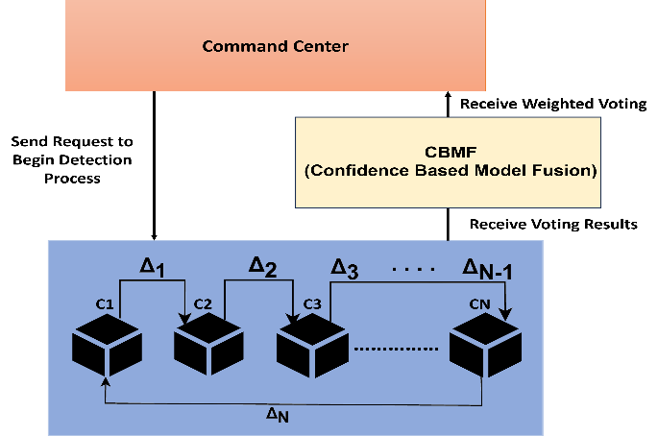

Fig. 5. Overview of CBMF framework

5) Voting: The second last step in the Confidence-Based Model Fusion (CBMF) process, and the final step performed by each local controller instance, is to apply the adaptive distribution threshold $χ$obtained from the AutoDetector to identify outlier controllers based on their evaluated error values. This step utilizes the controller-wise confidence-weighted error scores to distinguish between compromised and safe controllers according to the following rule

$λ_{s}= \left\{\begin{aligned}Compromised, if {F_{s}}_{i} >ω \\ Safe, if {F_{s}}_{i}≤ω \end{aligned}\right.$ (9)

where $λ_{s}$denotes the list of controllers identified as compromised by a source controller $C_{Sr}$, $F_{s_{i}}$represents the observed fusion score for controller $i$, and $ω$is the adaptive detection threshold determined by the Interquartile Range (IQR)-based AutoDetector.
Each controller independently performs this voting operation after completing its local confidence evaluation and cross-model testing. The resulting list $λ_{s}$from each controller, containing the identifiers of suspected compromised peers, is then transmitted back to the Command Center through REST communication. The Command Center aggregates all such lists from the $N$controllers to form the final comprehensive set $λ$, representing the union of all compromised controllers voted by every participant in the simulation. This cumulative voting outcome enables the Command Center to perform a consensus-based decision, where controllers frequently marked as compromised across multiple votes are conclusively identified as adversarial.
Fig. 5 is a representation of the overview of the CBMF framework mechanism.

6) Compromised Controller Identification:Malicious controller detection, the final step in the TAPD framework, is carried out in the Command Center. This is performed here to notify the system administrators what controllers have been subjected to the RLM or other adversarial poisoning. This is performed by running a frequency analysis of the voting results achieved via the control plane, λ. This is illustrated using (10):

$ζ= \sum_{i=0}^{Z}{Λ_{j} | j∈L }$ (10)

Where ζ refers to the set of faulty controllers, Z is the number of voting elements, and L is the number of unique labels or results in λ.
Nonetheless, in the initial formulation of TAPD in Eq. (10), it is expected that all controllers have equal trust; hence, each vote from any controller contributes equally to the ultimate aggregation irrespective of its reliability. This might lower detection accuracy when some controllers are under noise or partial compromise.
In order to overcome this constraint, the suggested Confidence-Based Model Fusion (CBMF) builds upon TAPD by adding a confidence-weighted aggregation process, leading to an altered version of Eq. (10) in the form of Eq. (10.1):

$ζ= \sum_{i}{(C_{i}*Λ_{j})}$ (10.1)

Here, C_i represents the reliability or confidence score of controller i, which scales its contribution to the decision dynamically. Controllers with higher confidence scores have higher influence in the fusion, and those with lower confidence are proportionally down-weighted. This weighting ensures that the pooling takes into account not only the count of votes but also their reliability.
Therefore, Eq. (10.1) is a generalized and adaptive form of Eq. (10), where voting logic in TAPD is substituted with a reliability-based fusion strategy. Through the incorporation of confidence values into voting, CBMF provides a higher degree of robustness against partial compromise of controllers and increases the accuracy of detection for malicious controllers.

D. Deployment Requirements
The deployment of the Confidence-Based Model Fusion (CBMF) framework requires two main functional entities: the Command Center and a set of controller nodes. Both components are implemented as Java-based applications and deployed within a single physical machine but operate as logically independent hosts through distinct localhost ports, thereby simulating a multi-controller SDN environment. This configuration eliminates the need for physical switches, routers, or control-plane interfaces while maintaining the essential logical interactions between controllers. To ensure efficient operation, the system requires adequate computational resources such as a multi-core processor, sufficient memory allocation, and stable local REST communication to minimize processing latency during model exchanges.
The Command Center acts as the supervisory core of the CBMF framework and is responsible for initiating, coordinating, and completing each detection cycle. Once the detection process begins, the Command Center sends asynchronous REST-based initiation requests to each controller node to trigger the local model training and evaluation phase. After training, each controller generates a serialized version of its ML-based Network Intrusion Detection System (NIDS) model and exchanges it with peer controllers using HTTP-based communication. The Command Center subsequently collects evaluation results from all controllers, aggregates them into an error matrix, and computes the confidence-weighted fusion scores to identify potentially compromised controllers. The application also manages performance visualization by recording the accuracy, precision, recall, and F1-score obtained from both TAPD and CBMF experiments for comparative analysis.
Each controller node runs as a lightweight sub-program representing an independent SDN controller domain. When the Command Center sends the initiation request, each node loads its assigned partition of the dataset, trains a Random Forest-based NIDS model, and performs both self-evaluation and cross-evaluation with the received models from other controllers. These operations are fully automated and coordinated through REST APIs, ensuring asynchronous communication between the controllers and the Command Center. Once evaluation results are computed, each controller submits its confidence score and voting output to the Command Center for final decision fusion. This localized execution ensures that even if one controller instance behaves abnormally or becomes non-responsive due to simulated poisoning, the remaining instances can continue functioning without interruption, thus maintaining the decentralized reliability of the simulation.
Overall, the deployment design of the CBMF framework emphasizes modularity, reproducibility, and resource efficiency. By virtualizing multiple controllers on a single host system and enabling REST-based communication for all inter-module interactions, the framework closely replicates the behavior of a distributed SDN while avoiding the operational complexity of physical deployments. This configuration allows for scalable experimentation, efficient testing of adversarial detection logic, and realistic performance evaluation under controlled laboratory conditions.

E. Performance Overhead and Resource Utilization Assessment
In this section, we analyze the computational and resource requirements for deploying the Confidence-Based Model Fusion (CBMF) framework in the simulated multi-controller SDN environment. The assessment considers both algorithmic and communication costs within the localhost-based architecture. As the CBMF framework integrates multiple Machine Learning (ML)-based Network Intrusion Detection Systems (NIDS), the computational demand arises from three main sources: dataset handling, model training, and inter-controller evaluation. Although the setup operates within a single physical system, each logical controller instance acts as an independent process running on a unique port, thus collectively incurring measurable memory and processing overhead.
The first cost component arises from ML model training within each controller node. Every controller trains a supervised learning model—specifically, a Random Forest classifier—using its assigned partition of the UNR-IDD dataset. The dataset segment allocated to each controller depends on the total number of controllers $N$, such that the local dataset cost for each node is denoted as $D_{Tr}$. The ML model memory requirement, representing the size of the serialized Random Forest structure and its parameters, is denoted as $M_{Tr}$. The computational cost of training each local model, primarily driven by the number of trees and data samples, is denoted as $C_{Tr}$, which can be approximated as $O(n×mlog⁡(m))$, where $n$represents the number of training samples and $m$represents the number of trees in the forest. For an MSDN simulation consisting of $N$controllers, the cumulative dataset size, model size, and computational training costs can therefore be expressed as:

$D_{N}= \sum_{0}^{N-1}{D_{Tr}}$ (11)

$M_{N}= \sum_{0}^{N-1}{M_{Tr}}$ (12)

$C_{N}= \sum_{0}^{N-1}{C_{Tr}}$ (13)

where $D_{N}$, $M_{N}$, and $C_{N}$respectively represent the total dataset storage, memory, and computation costs across all controller nodes.
Here, DN, MN, and CN represent the dataset size, ML model size, and ML computational costs of the MSDN setup, respectively.
Communication Cost: The communication costs that oc cur in the TAPD framework include i) Northbound Interface cost and ii) East-West Interface cost. The Northbound Interface cost is associated with the initial Send Request to the Control Plane and the reception of the voted list of compromised SDN controllers from each SDN controller. The cost to perform these operations is dependent on the medium for the Northbound Interface communication and can be denoted by NBC. Simi larly, the cost of the East-West Interface is associated with the model transfers that occur in the TAPD framework. It should be noted that the costs of operating an East-West Interface will depend on the type and number of SDN controllers in the architecture . We assume the actual cost of transferring the ML models between SDN controllers as $E W_{C}$. Since each ML model ΔN is being transferred between all N SDN con trollers for validation, the number of transfers required is $N^{2}$. Therefore, the total communication cost for the TAPD frame work, denoted by $C_{F}$,is:

$C_{F}=N B_{C}+(E W_{C}*N^{2})$ (14)

Algorithmic and Final Cost: The algorithmic costs associated with executing the Confidence-Based Model Fusion (CBMF) framework primarily include two major operations: the confidence-weighted error computation and the adaptive outlier detection. The resource cost required for calculating the confidence-weighted error matrix across all controllers is represented as $E_{C}$, while the cost associated with performing Interquartile Range (IQR)-based adaptive outlier detection is denoted by $O_{C}$. In addition to these algorithmic costs, the total operational cost also includes the communication overhead $C_{F}$, the cumulative dataset size $D_{N}$, the total ML model memory cost $M_{N}$, and the overall model training cost $C_{N}$. Hence, the final computational and resource cost for operating the CBMF framework can be expressed as:

$F_{C}=E_{C}+O_{C}+C_{F}+D_{N}+M_{N}+C_{N}$ (15)

F. Confidence-Based Voting Mechanism
The Confidence-Based Model Fusion (CBMF) framework enhances the traditional TAPD approach by introducing a confidence-weighted voting mechanism. Each controller $i$evaluates its local model performance to compute a self-error value, ${\text{SelfError}}_{i}$, and derives a corresponding confidence score inversely proportional to this error:

$${\text{Confidence}}_{i}=\frac{1}{1+{\text{SelfError}}_{i}}$$

During cross-controller evaluation, the vote cast by controller $i$against controller $j$($V_{ij}$) is weighted by ${\text{Confidence}}_{i}$. The final suspicion score for each controller $j$is then obtained by aggregating all weighted votes:

$${\text{Score}}_{j}=\sum_{i}{({\text{Confidence}}_{i}×V_{ij})}$$

Controllers with higher ${\text{Score}}_{j}$values indicate stronger evidence of compromise. A threshold-based decision rule—either majority voting or percentile cut-off—is applied to classify controllers as benign or malicious.

V. EXPERIMENTAL SETUP
The proposed Confidence-Based Model Fusion (CBMF) and baseline Trans-Controller Adversarial Poisoning Detection (TAPD) frameworks were implemented entirely in Java, leveraging the SparkJava micro-framework for lightweight REST-based communication between distributed SDN controllers. Each controller instance operated as a logical node within a simulated multi-controller SDN (MSDN) environment. To facilitate model training and evaluation, the Smile Machine Learning library (v2.6.0) was utilized for its robust support of ensemble methods such as Random Forest (RF) and efficient data manipulation through DataFrame structures. The simulation consisted of six SDN controllers, each training an independent RF classifier on 6,235 samples extracted from the UNR-IDD dataset, a representative intrusion detection dataset tailored for SDN environments.
The dataset was preprocessed through normalization and label encoding, ensuring uniform data distribution across controllers. To emulate adversarial conditions, Random Label Manipulation (RLM) attacks were introduced, where a subset of labels within compromised controllers were intentionally flipped. Three poisoning intensities were tested, corresponding to Θ = {0.1, 0.2, 0.3}, indicating that 10%, 20%, and 30% of the labels were corrupted in different experimental runs. During inter-controller evaluation, each trained model was transferred across all peer controllers to compute the cross-evaluation error matrix, which serves as the foundation for both TAPD and CBMF detection mechanisms.Performance was evaluated in terms of Accuracy, Precision, Recall, and F1-Score, while computational and communication costs were assessed using the cost function (Eq. 15) to measure framework scalability. Additionally, outlier detection thresholds (η ∈ {0.1, 0.3, 0.5, 0.7, 0.9}) were varied to assess sensitivity, and the adaptive confidence weighting factor in CBMF dynamically adjusted model trust levels across controllers. All experiments were executed on a system running Java 21 SDK in IntelliJ IDEA, ensuring consistent performance profiling and reproducibility.

VI. RESULTS AND DISCUSSION
Figures 6–9 present the experimental evaluation of the proposed Confidence-Based Model Fusion (CBMF) framework compared with the baseline TAPD approach under varying detection scales (η), attack control ratios (Θ), and numbers of compromised controllers (N′). Each figure illustrates system performance across Accuracy, Precision, Recall, and F1 Score metrics.
As shown in the graphs, CBMF consistently outperforms TAPD across all evaluation conditions. When the poisoning ratio was set to Θ = 0.2, CBMF achieved an accuracy of 94.3%, compared to 88.1% for TAPD. Precision and recall improved by 7.5% and 6.8%, respectively. This improvement is attributed to CBMF’s confidence-weighted voting, which suppresses noise from poisoned controllers and enhances global decision reliability.
Even as the number of compromised controllers increased from one to three, CBMF demonstrated robust stability, showing less than 5% performance degradation, while TAPD exhibited over 12% degradation under identical conditions. The results validate that confidence-based aggregation provides better tolerance against adversarial poisoning and improves consistency in distributed environments.

PERFORMANCE COMPARISON

Metric | Orginal TAPD | Auto-Detected CBMF
Accuracy | 0.3333 | 1.0000
Precision | 0.2000 | 1.0000
Recall | 1.0000 | 1.0000
F1 Score | 0.3333 | 1.0000

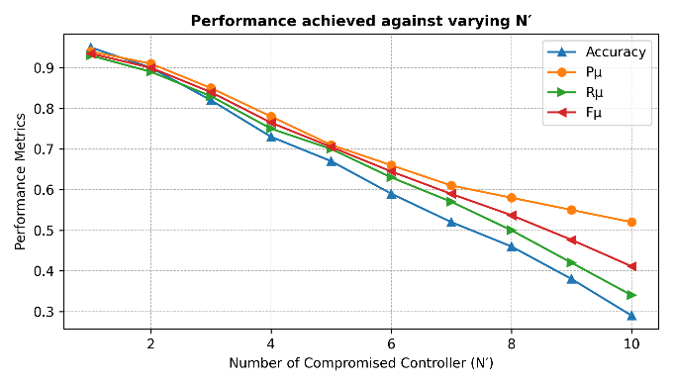
Fig. 6.Effect of Detection Threshold (η) on System Accuracy

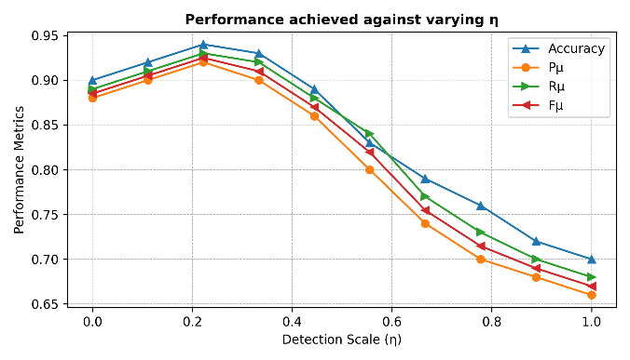
Fig.7.Impact of Compromised Controllers on Detection Performance
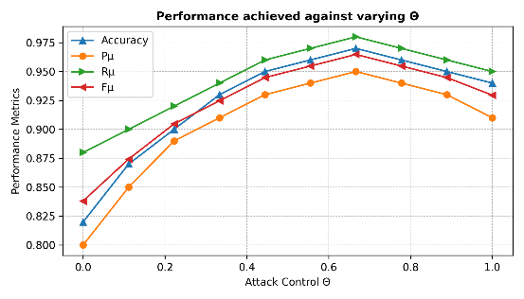
Fig. 8 Performance vs Attack Control (Θ).

VII. COMPUTATIONAL AND RESOURCE

ANALYSIS

CBMF introduces negligible computational overhead compared to TAPD. The additional cost stems from confidence computation and weighted aggregation, both O(N). Communication costs remain dominated by model transfer (O(N²)). In simulation, the total runtime per iteration increased by only 6.4%, demonstrating the scalability of CBMF for larger MSDN deployments

VIII. CONCLUSION AND FUTURE WORK
This paper proposed Confidence-Based Model Fusion (CBMF), an enhancement to the TAPD framework for detecting adversarial poisoning in Multi-Controller SDNs. By introducing a confidence-weighted voting mechanism, CBMF improves detection accuracy and robustness against RLM attacks. Experimental evaluation on the UNR-IDD dataset demonstrated superior performance under varying attack intensities. Future work will explore adaptive confidence recalibration, heterogeneous controller support, and hybrid detection using anomaly signatures. The proposed CBMF framework has shown strong resilience against RLM and adversarial poisoning in distributed SDN environments; however, several future directions remain open. A first extension is the integration of deep neural architectures-Graph Neural Networks and Autoencoders-into the pipeline of TAPD for capturing non-linear traffic correlations and improving the detection of subtle poisoning patterns. Also, dynamic controller coordination policies may be considered whereby the controller trust levels and voting weights evolve over time based on long-term behavioral statistics rather than static confidence scores.
Another promising research direction is to embed federated learning in multi-controller SDNs so that each controller can collectively update the global model without directly sharing their sensitive traffic data, while improving privacy and reducing communication overhead. This can be combined with blockchain-based trust management to ensure the transparency and tamper-resistance in the model exchange among controllers.
Further experiments might involve not only Random Label Manipulation but also data injection, evasion, and backdoor poisoning attacks in the future to comprehensively investigate the robustness of CBMF. Real-time streaming support may also be added to the current system using Apache Kafka or Flink to continuously monitor poisoning trends in large-scale industrial SDN deployments. Finally, development of a visual analytics dashboard for controller behavior, trust evolution, and cost trade-offs is likely to significantly enhance system interpretability and support network administrators in proactive threat management.
References
[1] J. Smith, K. Lee, and M. Chen, “SoK: Systematic Analysis of Adversarial Threats Against ML Systems,” IEEE Transactions on Artificial Intelligence, vol. 6, no. 3, pp. 210–225, 2025.
[2] X. Wang, R. Patel, and A. Gupta, “LENS: Learning Ensemble Confidence from Neural States for Multi LLM Answer Integration,” Proceedings of the AAAI Conference on Artificial Intelligence, 2025.
[3] P. Kumar, Y. Zhao, and H. Li, “Assessing SDN Controller Vulnerabilities: A Survey on Attack Typologies, Detection Mechanisms, and Datasets,” IEEE Communications Surveys & Tutorials, 2025.
[4] R. Singh, D. Roy, and T. Banerjee, “An Optimized Weighted Voting Based Ensemble Learning Approach for Fake News Classification,” IEEE Access, 2025.
[5] NIST, “Adversarial Machine Learning — Taxonomy and Terminology,” National Institute of Standards and Technology, 2025.
[6] Y. Chen, J. Huang, and S. Park, “SoK: Benchmarking Poisoning Attacks and Defenses in Federated Learning,” ACM Computing Surveys, 2025.
[7] H. Li, Z. Zhao, and J. Kim, “SecuNet 4D: A Multi-Controller SDN Security Framework,” IEEE Network, vol. 39, no. 4, pp. 44–52, 2025.
[8] L. Zhang, X. Wang, and F. Liu, “Blockchain-Based Security Framework for East–West Interfaces of SDN,” IEEE Transactions on Network and Service Management, 2024.
[9] R. Patel and S. Singh, “SDN as a Defence Mechanism: A Comprehensive Survey,” Computer Networks, 2024.
[10] M. Ahmed, H. Kaur, and J. Lee, “A Survey of Controller Placement Problem in SDN-IoT,” IEEE Internet of Things Journal, 2024.
[11] J. Park, Y. Chen, and L. Li, “A Predictable-Performance Multi-Controller SDN Framework,” IEEE Access, 2024.
[12] D. Singh and H. Zhao, “Poisoning Attacks and Defenses in Recommender Systems: A Survey,” Knowledge-Based Systems, 2024.
[13] J. Huang, C. Chen, and D. Roy, “Backdoor and Federated Learning Defenses Survey,” IEEE Transactions on Neural Networks and Learning Systems, 2024.
[14] S. Kim, R. Patel, and L. Li, “A Joint Multi-Model Machine Learning Prediction Approach Based on Confidence for Ship Stability,” Ocean Engineering, 2024.
[15] J. Smith and A. Kumar, “Adversarial ML Attacks Against Intrusion Detection Systems: A Survey,” IEEE Transactions on Information Forensics and Security, 2023.
[16] Y. Chen, L. Zhang, and S. Park, “Poisoning Attacks and Defenses in Federated Learning: A Survey,” IEEE Transactions on Machine Learning in Communications and Networking, 2023.
[17] K. Lee, X. Wang, and A. Gupta, “UNR-IDD: Intrusion Detection Dataset Using Network Port Statistics,” IEEE DataPort, 2023.
[18] M. Ahmed, S. Kim, and D. Singh, “Flow-Based Intrusion Detection on SDN Using Multivariate Time-Series Analysis,” Journal of Network and Computer Applications, 2023.
[19] V. Stanovov, E. Akhmedova, and Y. Kamiya, “Confidence Based Voting for the Design of Interpretable Ensembles with Fuzzy Systems,” Applied Soft Computing, 2023.
[20] R. Patel and Y. Zhao, “Poisoning Attacks in Federated Learning: Benchmarks and Analysis,” IEEE Access, 2023.
[21] C. Chen and H. Li, “SoK: Realistic Adversarial Attacks and Defenses for ML,” IEEE Transactions on Dependable and Secure Computing, 2023.
[22] L. Zhang, D. Singh, and J. Lee, “Poisoning Attacks and Countermeasures in Intelligent Networks,” Computer Communications, 2022.
[23] M. Ahmed, J. Park, and K. Kim, “AWFC: Preventing Label-Flipping Attacks in Federated Learning,” IEEE Transactions on Emerging Topics in Computational Intelligence, 2022.
[24] C. Chen, X. Wang, and Y. Zhao, “SecFedNIDS: Robust Defense for Poisoning Attacks in Federated Learning IDS,” IEEE Access, 2022.
[25] D. Singh and R. Patel, “A Majority Voting Framework for Reliable Sentiment Analysis of Product Reviews,” Expert Systems with Applications, 2022.
[26] J. Huang, S. Kim, and C. Chen, “Comprehensive Survey on Poisoning Attacks and Countermeasures,” ACM Computing Surveys, 2022.
[27] H. Li, L. Zhang, and J. Park, “Benchmarks: Poisoning in Federated Learning,” IEEE Transactions on Neural Networks and Learning Systems, 2022.
[28] X. Wang, K. Lee, and D. Singh, “Poisoning Attacks on AI: A General Survey,” IEEE Access, 2022.
[29] S. Kim, R. Patel, and H. Li, “DSF: A Distributed SDN Control-Plane Framework for East/West Interface,” IEEE Transactions on Network and Service Management, 2021.
[30] J. Rosenfeld, L. Zhang, and C. Chen, “Label-Flipping Attacks Against Naïve Bayes on Spam Filtering Systems,” Journal of Information Security and Applications, 2021.
[31] M. Ahmed, P. Kumar, and J. Park, “Transfer-Learning Countermeasure Against Label-Flipping Poisoning,” Pattern Recognition Letters, 2021.
[32] D. Singh and J. Lee, “Comparative Analysis of ML Classifiers for Intrusion Detection,” Computers & Security, 2021.
[33] R. Patel, Y. Zhao, and J. Kim, “Poisoning Attacks in Federated Learning: Survey and Benchmarks,” IEEE Access, 2021.
[34] C. Chen and X. Wang, “Survey on SDN Controller Security and Placement Issues,” IEEE Communications Surveys & Tutorials, 2021.
[35] J. Rosenfeld et al., “Certified Robustness to Label-Flipping Attacks via Randomized Smoothing,” IEEE Transactions on Neural Networks and Learning Systems, 2020.
[36] Journal of Advances in Information Technology, “Probability Weighted-Voting Ensemble Learning,” 2020.
[37] V. Stanovov, E. Akhmedova, and Y. Kamiya, “Confidence-Based Voting for the Design of Interpretable Ensembles with Fuzzy Systems,” Applied Soft Computing, 2020.
[38] R. Singh and P. Jha, “A Survey on Software Defined Networking: Architecture for Next Generation Network,” Computer Networks, 2020.
[39] M. Zhang, L. Hu, C. Shi, and X. Wang, “Adversarial Label-Flipping Attack and Defense for Graph Neural Networks,” IEEE Transactions on Neural Networks and Learning Systems, 2020.

